USE CASE:

ERD:

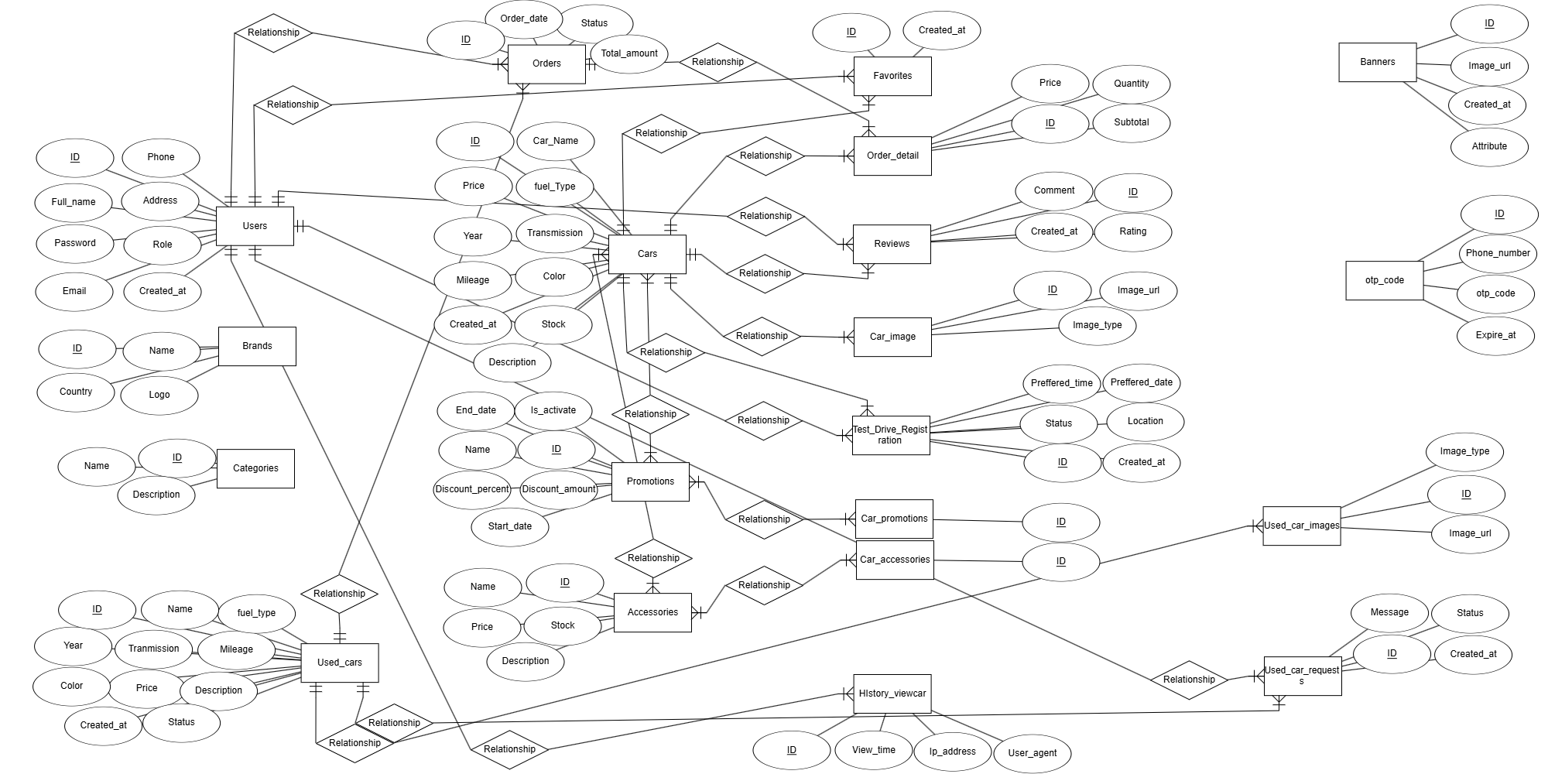

Link ERD: https://erdplus.com/edit-diagram/d3fd12c9-ca89-41cd-963e-95024bdd5c27

Giao diện:

